实验上机7：



#include <iostream>

#include <math.h>

#include <iomanip>

using namespace std;

int main(void){

double r1,p1,r2,p2;

cin>>r1>>p1>>r2>>p2;

double a1,b1,a2,b2;

a1 = r1*cos(p1);

b1 = r1*sin(p1);

a2 = r2*cos(p2);

b2 = r2*sin(p2);

double x1 = a1*a2-b1*b2;

double x2 = a1*b2+a2*b1;

if(x1>-0.005 && x1<0.005){

cout<<"0.00";

}else{

cout<<fixed<<setprecision(2)<<x1;

}

if(x2>-0.005 && x2<0.005){

cout<<"+0.00i";

}else{

if(x2>=0.0){

cout<<"+";

}

cout<<fixed<<setprecision(2)<<x2<<"i"<<endl;

}

return 0;}

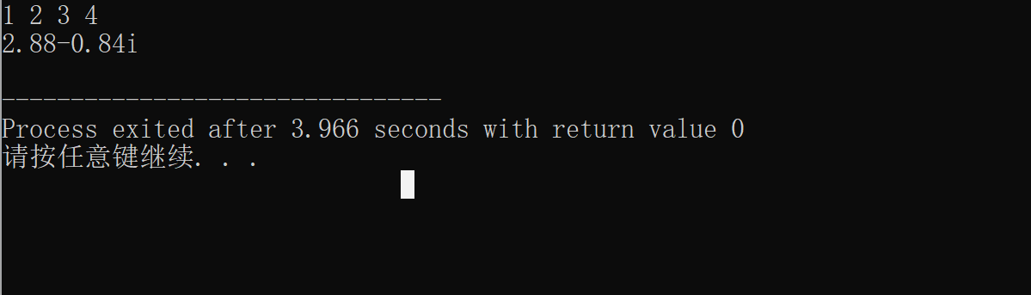

感想心得：

1、多上机实验！加深理解，这里多态比较难

2、要掌握运算符重载函数重载方法

**Copyright ©2021-2099 国家乐.All rights reserved**